Group 1: Prof. Dr. Mehmet Berilgen
Group 3: Assoc. Prof. Dr. Sükrü Özçoban
Group 4: Assoc. Prof. Havvanur Kılıç
Group 6: Assoc. Prof. Pelin Özener
Group 7: Asst. Prof. Dr. Nejat N. Çetinkaya

INS3121
November 21th, 2018

SOIL MECHANICS
MIDTERM I
Q.1/20p | Q.2/25p | Q.3/25p | Q.4/30p | TOTAL

Name and Surname:
Number:
Group:

- a) What are the Atterberg Limits? What is the importance of Atterberg Limits in engineering practice, explain briefly (6p).
b) Explain the terms of uniform soil and well-graded soil (4p).
c) What is Darcy’s Law? Write down Darcy’s Law equation and explain terms briefly (4p).
d) What is capillarity? What is its importance in Civil Engineering practice? (6p).

- For the given soils which the grain size distribution and consistency limits are given below;
- Draw the grain size distribution of the Soil A and Soil B and calculate the coefficient of uniformity (C_{u}) and coefficient of curvature (C_{c}) for the soil B (5p).
- Classify the soils, for which the grain size distribution and consistency limits are given below, according to Unified Soil Classification System (USCS) and American Association of State Highway and Transportation Officials (AASHTO) Classification System (16p).
- Explain which one of the soils can be used as a drainage material and a subgrade material in highway construction? (4p)
Sieve no | 4 | 10 | 20 | 40 | 60 | 100 | 200 | Pan
Sieve Diameter (mm) | 4.75 | 2 | 0.85 | 0.425 | 0.225 | 0.150 | 0.075
Soil A ƩFiner (%) | 100 | 97 | 90 | 78 | 58 | 50 | 45 | 45
Soil B ƩFiner (%) | 100 | 94 | 78 | 60 | 30 | 18 | 4 | 4

 | Liquid limit % (w_{L}) | Plastic limit % (w_{p}) | Plasticity index % (I_{p})
Soil A | 42 | 24
Soil B | - | - | -
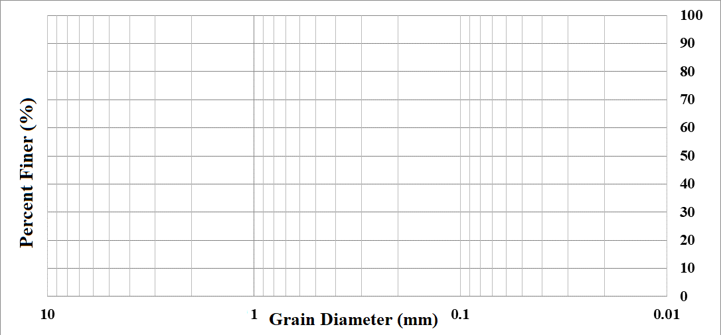

- A flow net under a concrete dam resting on a permeable soil is given in the figure. Saturated unit weight and permeability coefficient of the silty sand soil are 19.5 kN/m³ and 4.76x10⁻² cm/sec, respectively. Based on this information:
- Calculate the seepage loss under concrete dam per unit width (5p).
- Calculate the water pressures acting on points of A, B, C, and D (both points of A and D are the center points of the related equipotential lines) (16p).
- Determine whether there is a quick sand condition at the exit point of the concrete dam or not (4p).
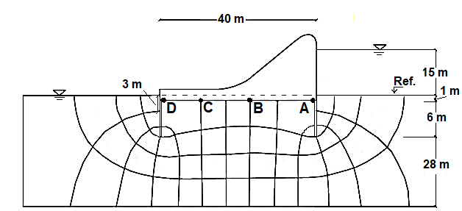

- For the given the soil profile below,
- Compute the total vertical stress, pore-water pressure, and effective vertical stress at points A, B and C (20p).
- Calculate the stress increase by Simplified and Boussinesq Method at Point D caused by foundation with dimensions of 4x6 m if a load of 3600 kN is acting uniformly (Point D is placed in the middle of the foundation. Neglect the self-weight of the foundation) (10p).
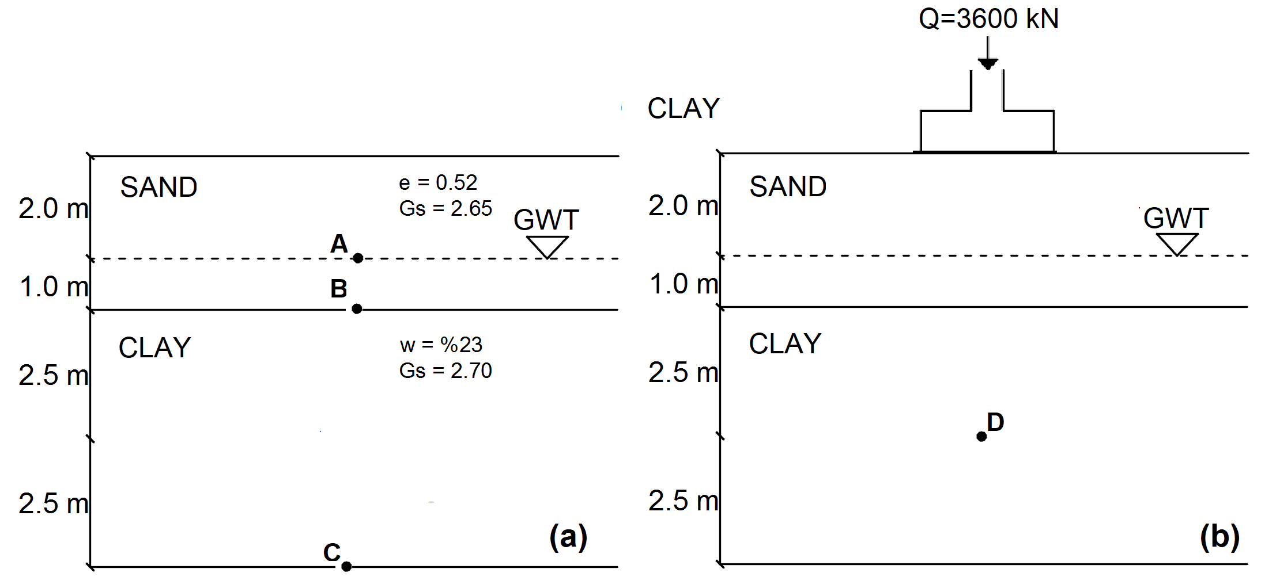

Time is 90 minutes. Good Luck…

